 | Dormant Consumers Key Insights
 | Audience Insights DRI: Alanna Shipley

Research Objectives  Understand the shopping behaviors and opportunities for the grocery shopper.  Methodology  Qualtrics Survey  - 1700 Completes across 4 groups (Active MAU turn Dormant, Dormant turned Active, Regularly visiting Dormant, Quarterly Active Dormant)  - In Field: May 13-17 | Research Background  Insert 2-5 lines or bullets summarizing the key background information for tee research  Key Research Documents  - Survey & Brief  - MAU Deep Dive

KEY RESEARCH FINDINGS: WHY DID CONSUMERS SLOW OR STOP ORDERING?

There is an immense pressure of financial strain right now making people reevaluate and interrogate where their money is being spent. This is causing consumers to evaluate every facet of what and where they are spending their money, including food delivery.
- Over 50% of Dormant consumers stated they intentionally stopped or slowed down their DoorDash orders which is +10 ppts lower than stated by the less involved Very Churned consumers talked to in Nov 2021.
- ~40% of Dormant consumers mentioned an increased awareness and interrogation of their spending due to the volatile financial situation and reducing their ordering of DoorDash because of it.
Delivery is being characterized as more of a luxury and less of a necessity. With this shift comes dissatisfaction with the perceived value to cost expectation. Consumers are evaluating each part of the cost of delivery more driving them to notice fees and cost more.
- About ~35% of Dormant consumers mentioned DoorDash fees as a barrier with a large number specifically calling out a perception of higher and additional fees that they are unhappy with. Some consumers are even mentioning the higher default tips as being a turn-off. Consumers are evaluating each line of their cost at checkout and due to financial strains leading to them no longer being able to justify paying the premium of delivery.
- About ~15% of Dormant consumers specifically called out the inflated prices on DoorDash versus what they see on restaurant menus as a deterrent for delivery; many deciding it is best to pick up themselves. Also tied to the consumers’ awareness of their spend is them mentioning doing more intentional comparisons to prices on Restaurant menus. While they do not blame DoorDash for this inflation, in the end, it keeps them from ordering. This is +5 ppts more unaided mentions than what we saw with Very Churned in Nov 2021.
Part of the cost/value evaluation comes a lower tolerance of delivery errors. There was over 50% more mentions of customer service, app, or delivery issues. While some mentioned these have happened before and were accepted, many are saying it is not acceptable given the fees and disposable income.
- At ~20% of total Dormant consumers mentioning customer service, app, food quality, or delivery time issues, it is clear that consumers’ expectations for delivery have increased. Consumers especially mentioned multiple canceled orders, trying to reach customer services about their issues with no resolution, and getting cold food. As consumers evaluate including delivery in their budget, they have become more vocal about negative experiences decreasing their value and justification for delivery. This is +10 ppts more than what we heard with Very Churned consumers back in November 2021.
- ~7% of the consumers specifically mentioned delivery instructions not being followed by Dashers causing them to not be able to trust DoorDash to follow thru.
A higher propensity of Dormant consumers called out specific competitor comparisons than what we saw with Very Churned groups before they left DoorDash, suggesting there is more direct evaluation happening. As Dormant consumers are deciding to indulge in delivery, they are looking across apps to determine the best deals and benefits and our competitors are winning with this group these.
- UberEats was called out by ~15% of consumers as a better alternative to DoorDash for many reasons. The top three being the mentioning of UberEats having more consistent promos with universal usage, perception of overall lower prices (likely linked to the first point), and not having as many delivery waiting issues. Dormant consumers are comparing totals across apps to get the best deal making the differences more prominent.
- About ~5% specifically called out benefits on other programs or getting them for free that they enjoy and ding DoorDash for not having more obvious benefits for loyalty. This includes the Marriott points accrual, Grubhubs lowest price promise, GrubHubs student offers, as well as subsidized fees offered to them

KEY QUOTES: WHY DID CONSUMERS SLOW OR STOP ORDERING?
~40% of Dormant consumers mentioned an increased awareness and interrogation of their spending due to the volatile financial situation. As a results consumers are evaluating delivery as more of a luxury versus a necessity.
- With costs rising so much for items in every facet of life, a luxury like having food delivered has become far tougher to justify. Even with whatever “savings” I get from DashPass.
- [My partner and I] have come to rely on DoorDash a bit too much and found that we were wasting groceries/spending a lot more money. While I love the convenience, I unfortunately had to cut back on my doordash ordering to save money.
- I recently lost my job and have cut down on ordering to save money.
- The epidemic slowed us down with our income and couldn’t afford eating out as much.
- I've just been spending money on other things, so I don't really have much extra to spend on doordash.
- I slowed down on using doordash because I’m trying to save money. Everything is going up in price

About ~35% of Dormant consumers mentioned DoorDash fees as a barrier with a large number specifically calling out a perception of higher and additional fees that they are unhappy with. Some consumers are even mentioning the higher default tips as being a turn-off. Consumers are evaluating each line of their cost at checkout and due to financial strains leading to them no longer being able to justify paying the premium of delivery.
- Your end costs to the user are getting high. Some delivery fees that are $8.99 are ridiculous.
- I got tired of paying the fees. It’s not worth $30-$35 for a 20 dollar meal.
- There is a lack of clarity involving fees. I understand and agree that delivery is more expensive than picking up on my own but the amount of fees add up and there isn't clarity on them. Ordering lunch for just myself turns into a $30 ordeal.
- The additional cost of items and added fees in my area on top of being an “extended delivery area” fee when we are very close to freeway and many commercial/retail stores. We are simply a new construction subdivision that’s new to maps.
- High cost of using doordash. A simple food costs so much to get delivered. Everytime, i always thought the food wasnt worth the de facto mandatory tip, service fee and overpriced small portion of food.
- The prices are already more within the app for food, then you have tax, then delivery fees, THEN on top of that you tip. I would tip my drivers more / want to use more often if the add-on fees weren’t always at minimum an extra 7$ on top of what my price of food is, AND then another 5-7$ on tipping. I’d rather drive out and pick it up myself, and tip the hostess 3$.

About ~15% of Dormant consumers specifically called out the inflated prices on DoorDash versus what they see on restaurant menus as a deterrent for delivery; many deciding it is best to pick up themselves. Also tied to the consumers' awareness of their spending is them mentioning doing more intentional comparisons to prices on Restaurant menus. While they do not blame DoorDash for this inflation, in the end it keeps them from ordering.
- I began to realize that I was basically paying doubly the amount on food with delivery cost and fees that I may as well just go straight to the source.
- The reasoning for my absence of use for door dash would be the price for the food is more expensive through door dash ex(a single price for a chicken McGriddle would be $2.29 on the McDonald's menu but on doordash menu it will come out to $3.89)
- The price. I primarily use DoorDash for pickup, in order to avoid fees/tip. I realized that businesses have elevated prices on DoorDash, relative to their in-store price. So it simply doesn't make sense to order through the app just to pay more.
- In the past 30 days I have only ordered pickup myself to cut down on delivery costs.
- For instance, take a burger from In-N-Out; $14 for a complete combo meal, including a discount? When I don't even live nor order from any significantly price-discriminating setting (i.e., airport, theme park, etc.)? That's ridiculous! I had to intentionally ramp down my usage of DoorDash, especially for craving-ridden restaurant orders because of this excessive cost, excluding any additional surcharges (fees, membership, taxes, etc.).

At ~20% of total Dormant consumers mentioning customer service, app, food quality, or delivery time issues, it is clear that consumers’ expectations for delivery have increased. Consumers especially mentioned multiple canceled orders, trying to reach customer services about their issues with no resolution, and getting cold food. As consumers evaluate including delivery in their budget, they have become more vocal about negative experiences decreasing their value and justification for delivery.
- Quite often we would order dinner that would be confirmed then after anywhere from 5 minutes to 30 minutes the order would be canceled and by the time I was notified it was too late to order from somewhere else (so no dinner) and Is a hassle of trying to contact DoorDash we would be refunded but it’s still quite a hassle it doesn’t solve the initial problem of needing food or other items
- Door dash has in past times delivered late with my friends or me ordering during peak, so it's not reliable for delivery so I can't trust doordash during peak hours.
- I had a string of bad experiences right in a row so I decided not to use DoorDash services for a while. The problems were constantly not getting my correct order, despite special instructions left, and more than that every order had at least one or more items completely left out. For example I’d get only half of the items I ordered, and then the ones I got would be totally wrong! Then there was no way to ask DoorDash to go back and retrieve the missing items that I’d paid for!
- We were constantly having issues with using the Dashpass we were paying for. It said the card wasn’t eligible even though it was the same one we were using to pay for the subscription. It happened over and over and over. All the representatives would do was give a refund, which was definitely necessary, but many of them didn’t really care to help, it’s very frustrating to have to ask for that every single time, and I asked and asked for them to actually just fix whatever the problem was, and no one knew how. Some were very unhelpful and couldn’t care less.
- Because there is just to many times where you order food and or things and stuff is missing or you just don’t get and door dash will only refund so much plus you get charged so much extra for what would cost you 10$ would cost 20 or above with door dash and that not including what you have to tip, just to not get everything you ordered
- I stopped ordering due to a large amount of errors within the last few orders I received. Often something is wrong or entirely missing for my orders and DoorDash does not provide good support for this consistent issue. The cap of refunds is not fair when local restaurants and drivers are constantly messing up or not picking up full orders. It started to feel like a waste of money when over half the time I would order, something would be incorrect.

~7% of the consumers specifically mentioned delivery instructions not being followed by Dashers causing them to not be able to trust DoorDash to follow thru.
- My orders are frequently wrong, left at the wrong apartment door, and when I text the driver nothing happens. Customer service is not helpful
- The drivers don’t follow the delivery instructions very well. They always leave on my front porch but my instruction say to leave on side porch. There is no fence or anything. They just don’t read the delivery instructions and it’s frustrating
- They would leave my food outside on ground or don’t read or go by the instructions I gave

A small, but noticeable amount of Dormant consumers mentioned having specific payment/DP access/promo issues that are worthy to follow up to determine bigger issues.
- When I tried to use it I saw that my old credit card was listed. I tried to change it to my current card but was unable to.
- I also had recently had some payment issues with DoorDash, such as promotions not working correctly, and I did not want to continue having those issues.
- The reason I stopped was mainly b/c of my experience with trying to enrol for the DashPass. I have an RBC credit card that is eligible for the 12-month free subscription but have not been able to successfully activate that after numerous support calls. Each time, they have asked me to delete my credit card, log out of the app, re-download or login again, and re-enter the RBC credit card. They then advise that I should see a banner or a message on the home page with the RBC promo - I’ve never seen this. In the most recent call, the support person advised me that the promo won’t work for me b/c I’m from the US. I’m actually a Canadian resident, born &amp; raised in Canada, and signed up for DoorDash IN CANADA. As you can imagine, it’s been thoroughly frustrating.
- When I reached out to customer service, instead of refunding me with the original payment method the rep gave me Doordash credit without asking. When I reached out again to clarify, s/he claimed I was refunded and disconnected me from the chat. I had to contact customer service in a couple days again to fix the issue.

UberEats was called out by ~15% of consumers as a better alternative to DoorDash for many reasons. The top three being the mentioning of UberEats having more consistent promos with universal usage, perception of overall lower prices (likely linked to the first point), and not having as many delivery waiting issues. Dormant consumers are comparing totals across apps to get the best deal making the differences more prominent.
- Door dash also use to offer discounts but it's $3 off if I buy a coke. The other apps five 40% of 50, or 15 off store purchases of 45 or more, 20% off 30. There's just more customer appreciation. Everyone doesn't want a drink with their meal and everyone doesn't have a pet so those discounts only apply to a small portion of customers.
- I also look through all of my apps to see which one I can get the food I want with the lowest price but also the fastest to me. If I have to wait an hour on one app but only 30 mins on the other I’m picking the shorter wait time.
- It seems like uber eats has become cheaper than doordash by a couple of dollars per each order. While $2-3 is not a lot, I notice the price difference more now that costs of everything are going up. I was never unhappy with door dash, yet, the service is almost identical to uber eats so I go with the least expensive delivery service.
- The pricing… restaurants increase their prices so that they get their money and at the end we pay their membership.. Postmates and Uber eats have this problem too but with mixing giftcards and using cash back apps at the end I save money but can’t do it with your app.

About ~5% specifically called out benefits on other programs or getting them for free that they enjoy and ding DoorDash for not having more obvious benefits for loyalty. This includes the Marriott points accrual, Grubhubs lowest price promise, GrubHubs student offers, as well as subsidized fees offered to them
- I use Grubhub plus, better restaurant selection and love the $10 off one pick up order a month. This pays for membership
- Also, I only do pickup now. And I only order thru GrubHub when I can use the price match guarantee. This allows me to save the difference +$5 to use toward future order.
- I stopped because I was offered a free grubhub+ membership where I do not pay for delivery.
- I have a Grubhub+ benefit through work and I have been using that service more given that it is heavily subsidized by my employer
- .Grubhub has a program that gives students a free Grubhub+ subscription that eliminates delivery fee and a chunk of service fees. On the rare occasion I order out I tend to go with Grubhub because if that.
- Also you guys don’t offer any cash back for current costumers on any cash back apps like drop and etc but Postmates does. I like to order pick with your app and have subscription for offers but since the food prices are fake and high then it’s a loss for me.

KEY FINDINGS: WHAT ARE DORMANT CONSUMERS DOING WHILE BEING DORMANT

WHAT ARE DORMANT CONSUMERS DOING WHILE BEING DORMANT
- Over 50% of Dormant consumers have used an on demand delivery in the last 30 days, and 24-32% have ordered non-Rx items thru on-demand delivery in the last 30 days.
- 30-40% of Dormant consumers used UberEats with a higher rate for Regularly Visiting Dormant Cx. Additionally, about 20% of Dormant consumers have ordered from Instacart in the last 30 days.
- 1 out of 3 Visiting Dormant Cx said they ended up placing an order on another app when they visited but did not place an order. The same amount said they went to the store or restaurant and the same changed their plans and did not place an order or visit the store or restaurant.

KEY DATA: WHAT ARE DORMANT CONSUMERS DOING WHILE BEING DORMANT
The majority of Dormant consumers have used on demand delivery in the last 30 days, and 24-32% have ordered non-Rx items thru on demand delivery in the last 30 days.

Use of Third Party on demand delivery in the last 30 days
Any delivery | Non-Rx delivery
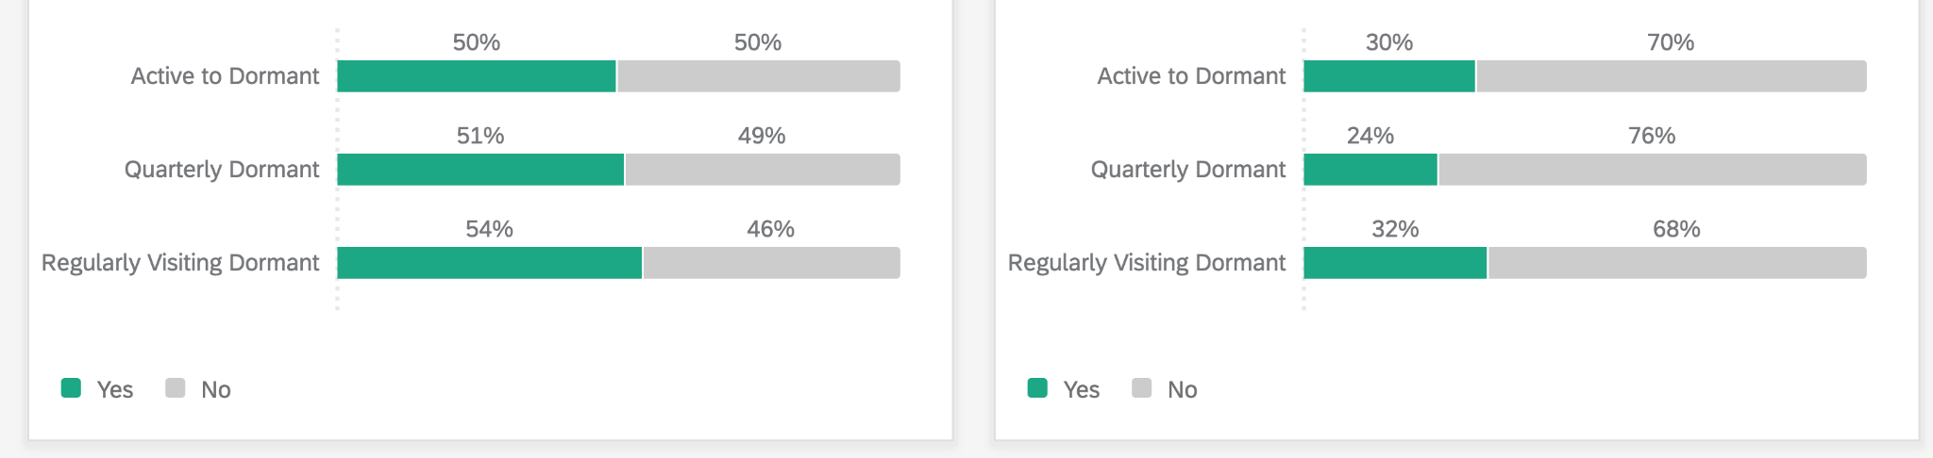

30-40% of Dormant consumers used UberEats with a higher rate for Regularly visiting Dormant Consumers. Additionally about 20% of Dormant consumers have ordered from Instacart before.

Stated App Usage in last 30 days
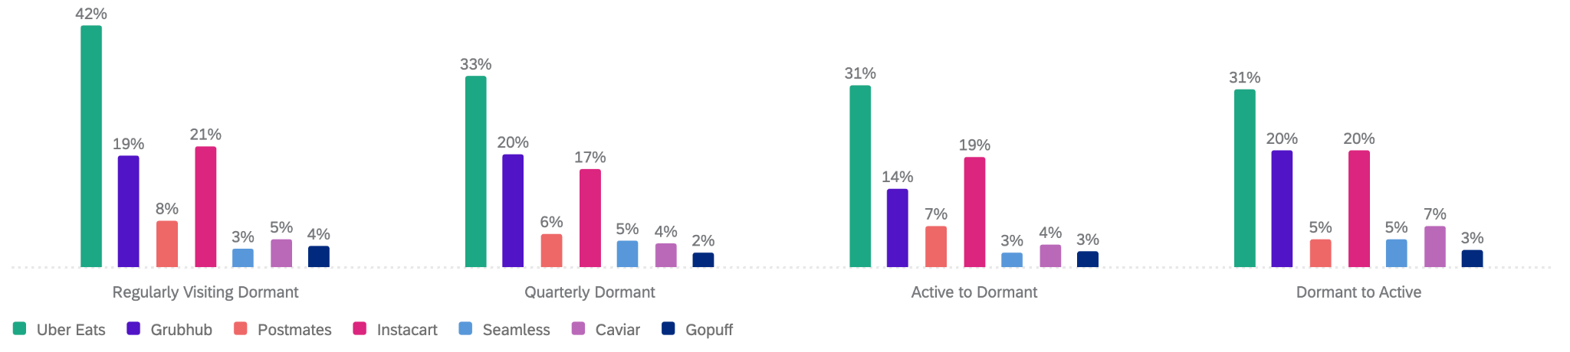

1 out of 3 Visiting Dormant Cx said they ended up placing an order on app. The same amount said they went to the store or restaurant and the same changed their plans and did not place an order or visit the store or restaurant.
The last time you remember visiting DoorDash and not placing an order, which of the following applied?
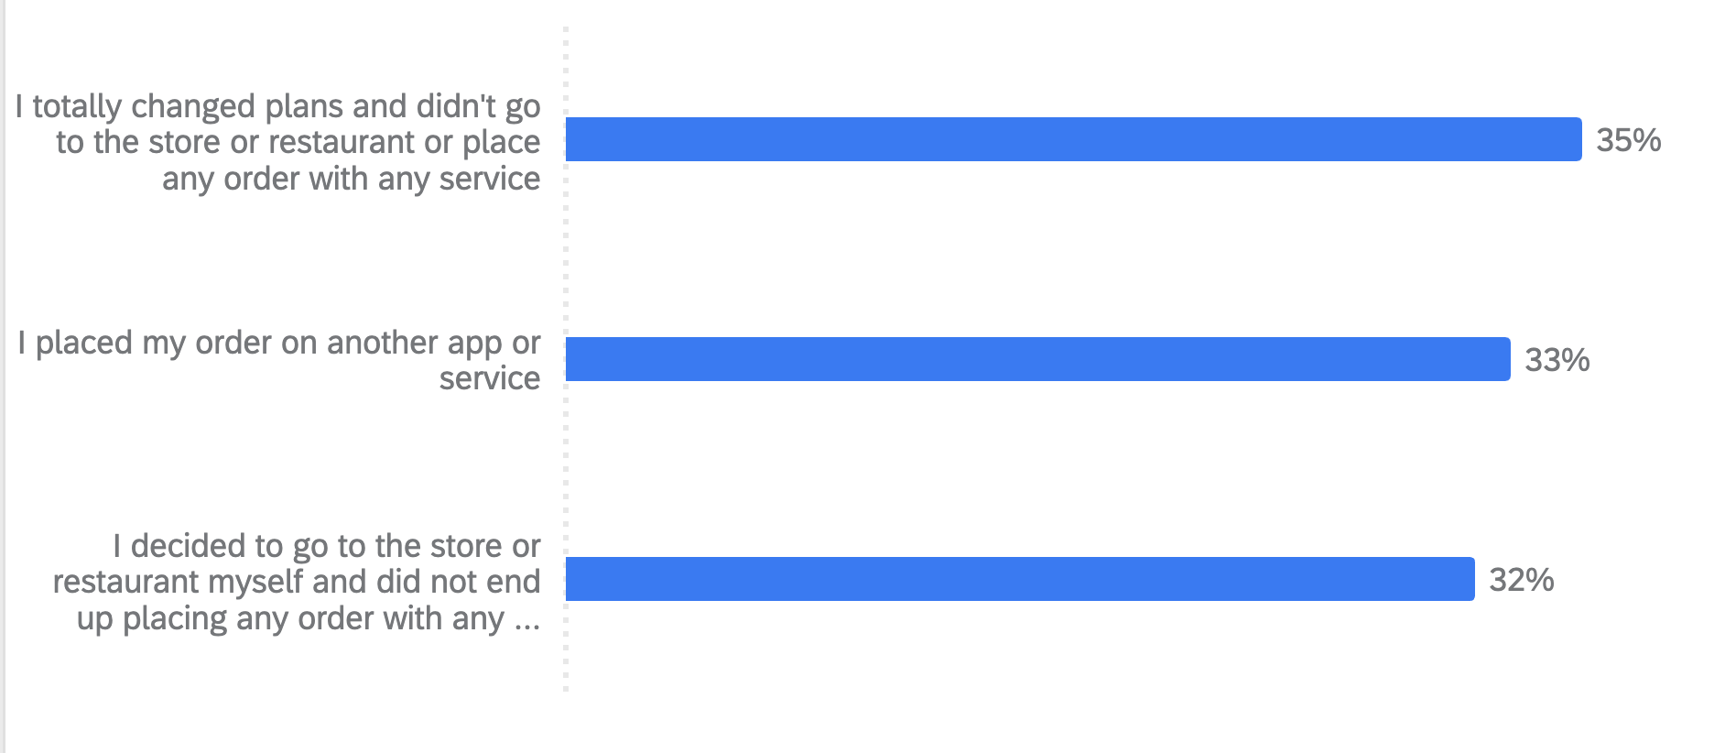

KEY FINDINGS: WHAT IS DIFFERENT ABOUT THE PROFILE OF A DORMANT CONSUMER?
- Dormant consumers are more likely to be Strategic Savers. Versus other delivery consumers they are:
  - More sensitive to fees: 50% more likely to believing delivery fees are high & 70% more likely to stop using an app due to delivery fees not being worth it
  - More financially conscious: 17% more likely to have concerns about money
  - More sensitive to inaccurate orders: 34% more likely to stop using a delivery app due to deliveres being inaccurate
  - More likely to do comparison shop: 18% more likely to say they need to confirm there is nothing better before making decisions. 41% more likely to check reviews & descriptions before deciding
- Regularly Visiting Dormant Cx are more likely to use another person’s DashPass account. Recently Active turned Dormant and Dormant turned Active are more likely to state they are paying full price for DoorDash
- The Regularly Visiting Dormant consumer is more likely to have an Uber One subscription. 10-16% of DoorDash Dormant consumers have an UberEats account.
- Dormant consumers with Uber One accounts are more likely to get it at a discount than DashPass users. Supporting UberEats having more discounts throughout its experience
- Regularly Visiting Dormant Cx are more likely to be younger (29%: 18-25) while Quarterly Dormant consumers are more likely to be older (26%: 41-55). Quarterly Dormant and Active to Dormantt consumers are more likely to be Male.
- More Regularly Visiting Dormant Cx & Active to Dormant consumers live alone. Additionally more Active to Dormant consumers have at least 1 child under 5 years old.
KEY DATA POINTS: WHAT IS DIFFERENT ABOUT THE PROFILE OF A DORMANT CONSUMER?
Dormant consumers are more likely to be Strategic Savers. This group is more sensitive to fees, more financially conscious, sensitive to inaccurate orders, and more likely to do comparison shopping. This explains why these experiences happening at the same rate as active consumers are impacting them more.

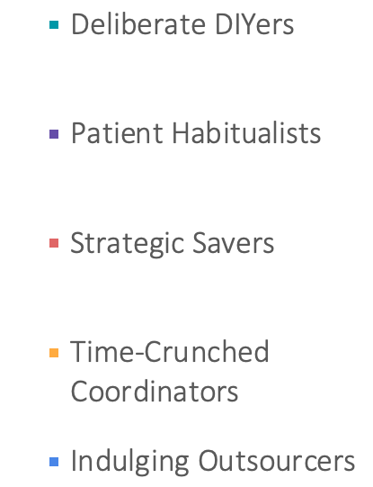 | 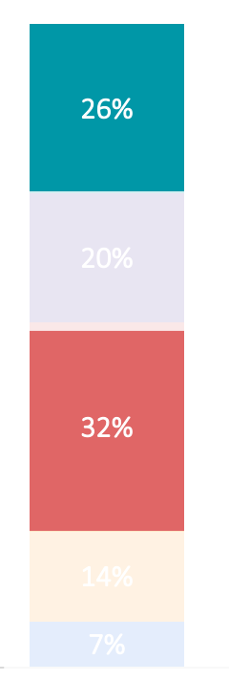

Regularly visiting Dormant consumers are more likely to use another person’s DashPass account. Recently Active turned Dormant and Dormant turned Active are more likely to state they are paying full price.
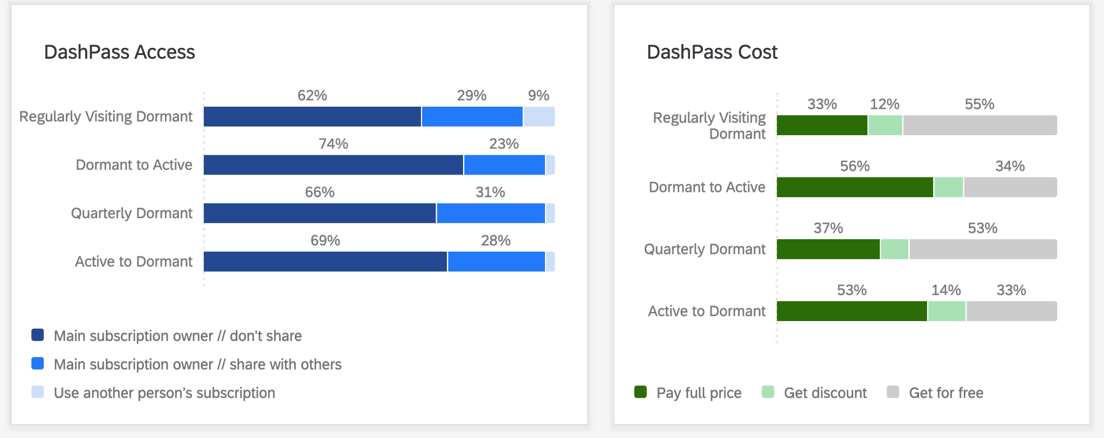

The regularly visiting Dormant consumer is more likely to have an Uber One subscription. 10-16% of DoorDash Dormant consumers have an UberEats account.
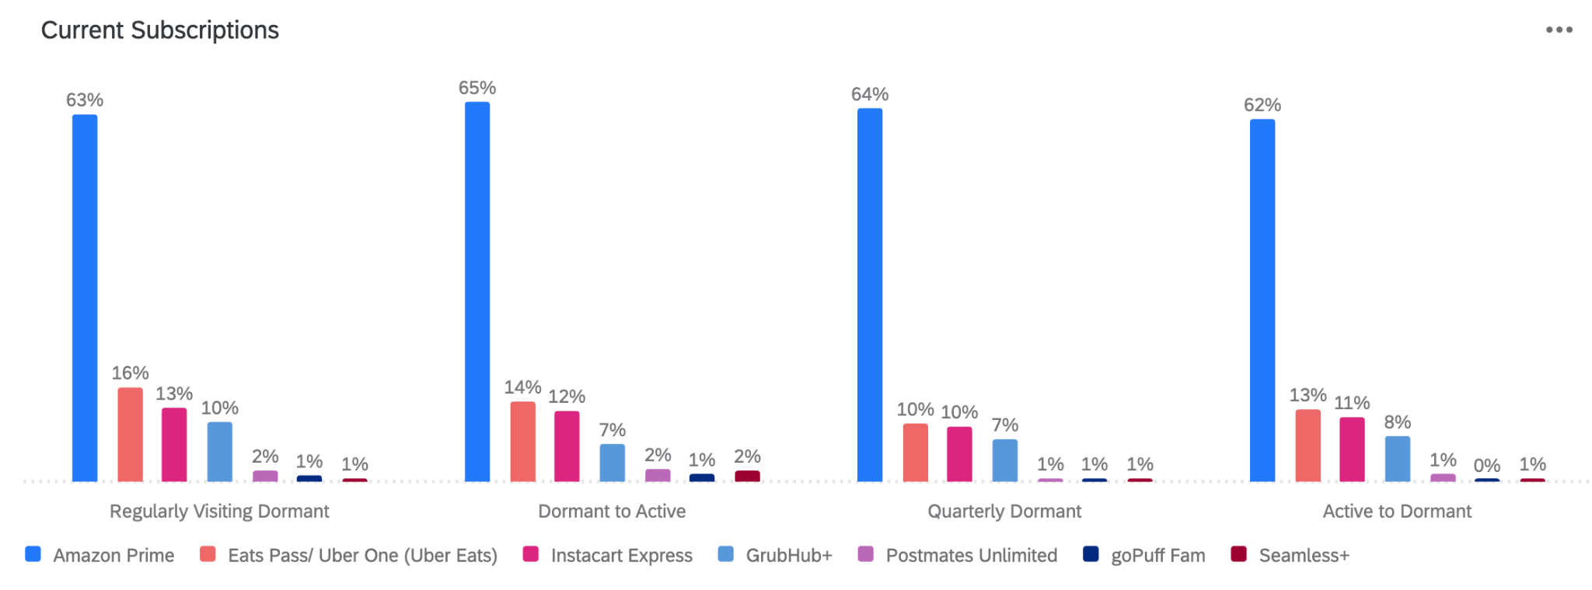
Dormant consumers with Uber One accounts are more likely to get it at a discount than DashPass users. Supporting UberEats having more discounts throughout its experience
Cost of Subscription (for those that have it)
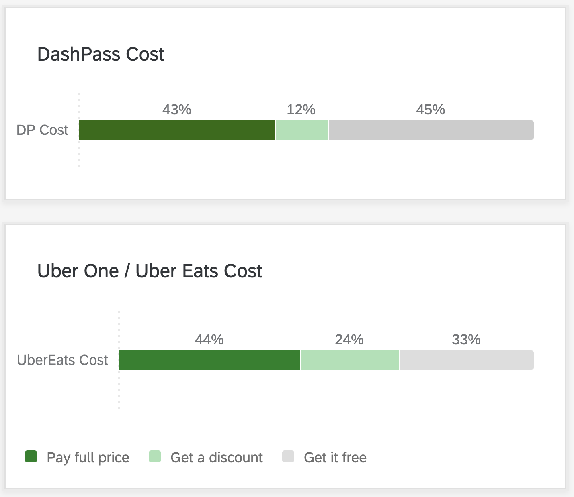

Regularly visiting Dormant consumers are more likely to be younger (29%: 18-25) while Quarterly Dormant consumers are more likely to be older (26%: 41-55). Quarterly Dormant and Active to Dormant consumers are more likely to be Male.

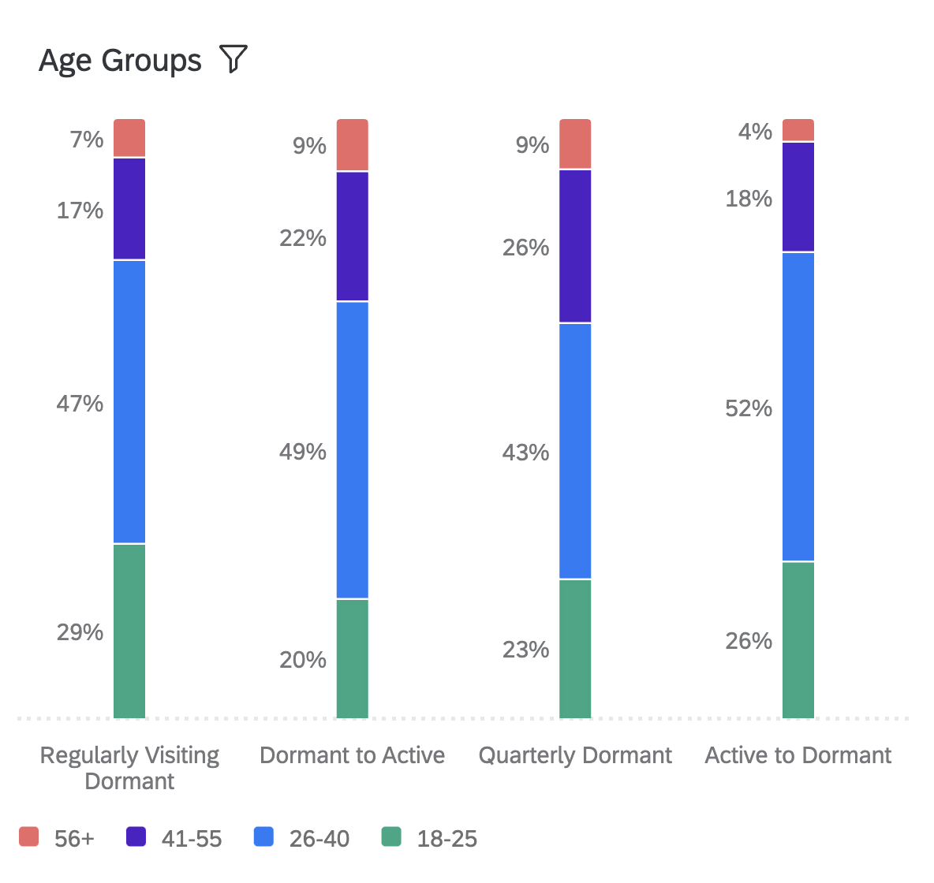 | 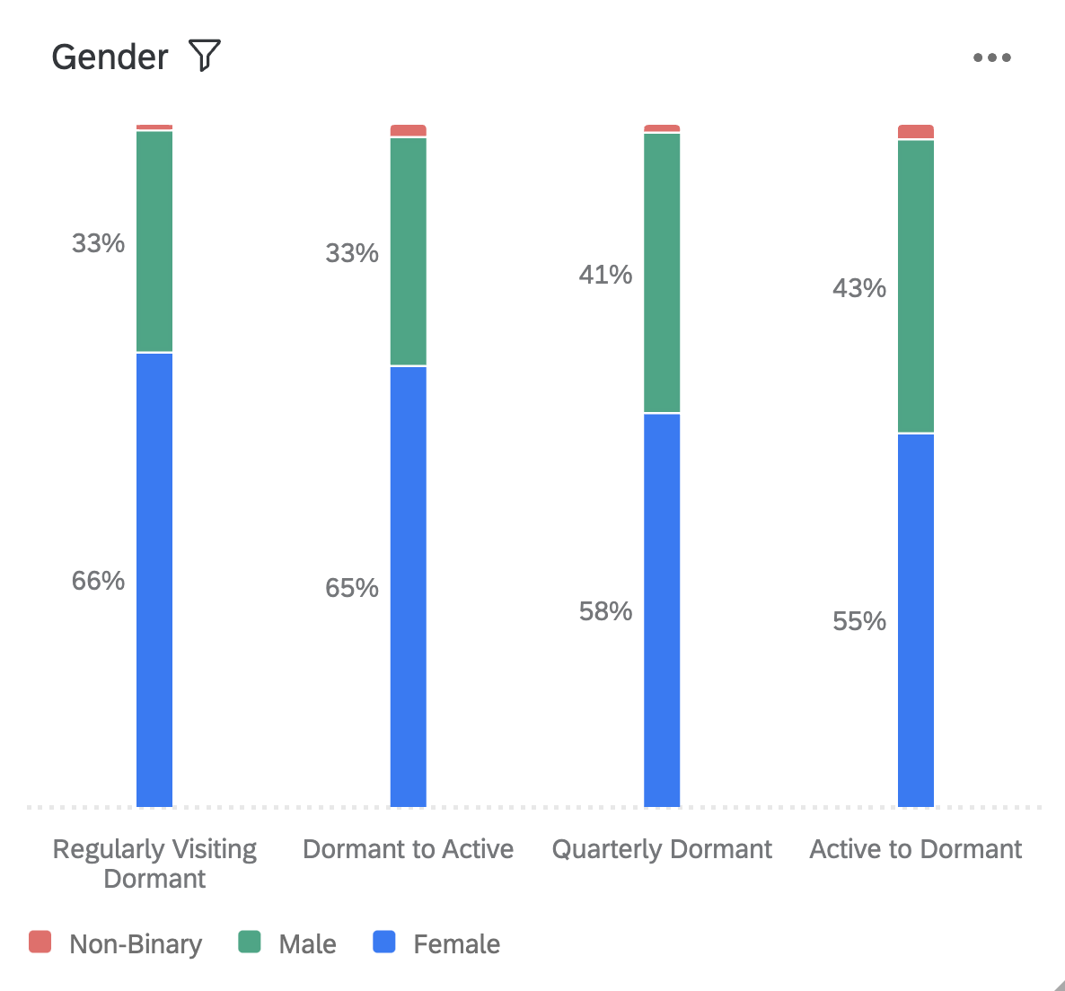

More Regularly visiting Dormant Consumers & Active to Dormant consumers live alone. Additionally more Active to Dormant consumers have at least 1 child under 5 years old.
 | Regularly Visiting Dormant | Dormant to Active | Quarterly Dormant | Active to Dormant
At least 1 other adult | 65% | 65% | 69% | 59%
Live alone | 26% | 20% | 19% | 24%
At least 1 child under 5 years old | 14% | 14% | 15% | 18%
At least 1 child 6-12 years old | 12% | 16% | 18% | 18%
At least 1 child 13-17 years old | 10% | 14% | 13% | 13%

THOUGHTS & ACTIVITY WITH DOORDASH
Current Dormant consumers more consciously changing their behaviors is further supported by them having a higher rate of intentionally stopping or slow down their DoorDash orders versus a less involved Very Churned consumer group in November

Slowing down or stop ordering intentions
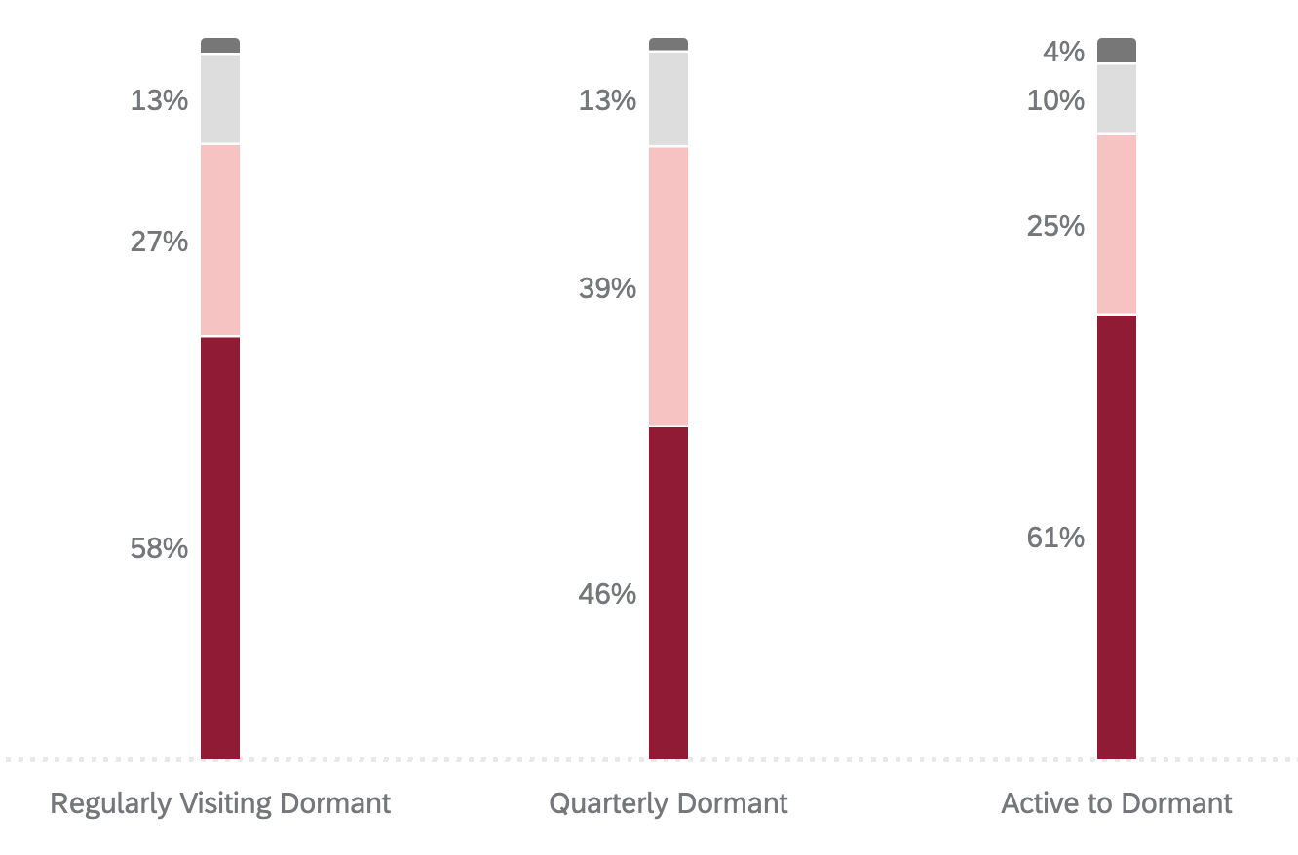 | 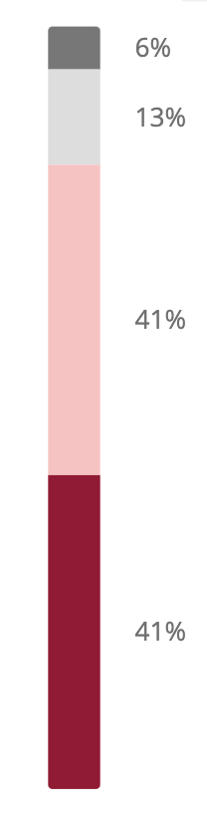
 | Very Churned (2021)
Regularly Visiting Dormant consumers and recently active Dormant consumers are more interested in grocery deliveries from DoorDash versus the other groups

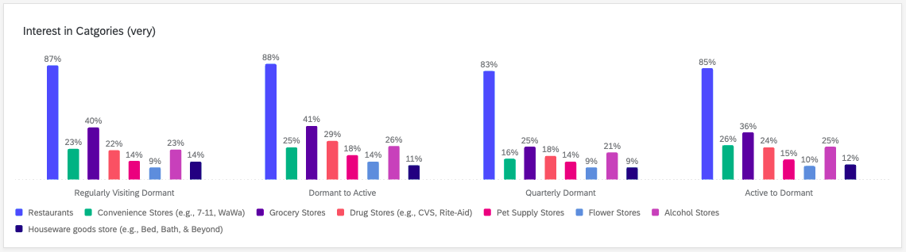

The top 3 tested reasons for slowing down orders are the same across groups (fees, inflation, and lack or promotions) but there are differences between groups. The regularly visiting and Quarterly Dormant consumer is more likely to say they switched apps; more Quarterly Dormant Cx started dining directly from restaurant, and more active to dormant had bad experiences with DoorDash and are cooking more.

 | Regularly Visiting Dormant | Quarterly Dormant | Active to Dormant
The delivery/service fees were too high | 58% | 54% | 48%
The prices of products on DoorDash are higher than what's in store or on the store's menu | 54% | 42% | 53%
DoorDash lacked promotions/deals | 43% | 38% | 34%
I started dining/ordering from restaurants directly | 25% | 30% | 24%
I started cooking more frequently | 24% | 24% | 31%
I switched to other apps such as UberEats, GrubHub, etc. | 23% | 21% | 14%
The restaurant/items I want to order are not on DoorDash | 17% | 20% | 16%
I had bad experiences using DoorDash | 15% | 15% | 23%
I felt guilty ordering delivery | 13% | 11% | 13%
I had frequent issues with food quality | 13% | 9% | 22%
I started a healthier lifestyle | 11% | 16% | 16%
I had issues with customer service | 8% | 5% | 12%
None of the above | 2% | 4% | 5%
I moved to a region without DoorDash | 1% | 1% | 2%
I found the DoorDash app hard/confusing to use | 1% | 1% | 1%

Across all groups, DoorDash is mostly thought of for when Cx do not feel like cooking. Dormant turned Active consumers are
more likely to think of or use DoorDash for more situations while Quarterly Dormant think of DoorDash the least. Active to Dormanat are more likely to think of or use DoorDash for when their routine changes or when they run out of grocery items.

How often do you think of or order from DoorDash when you experience the following types of situations? (%Often)
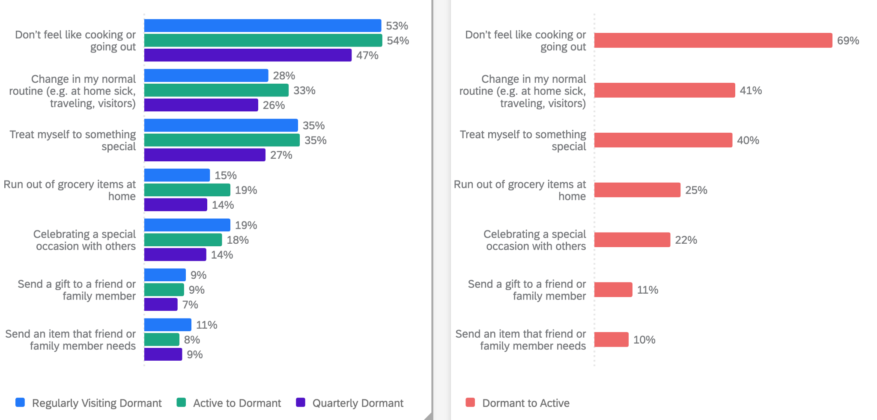

About 50% of currently Dormant consumers stated they are likely to order from DoorDash in the next 7 days and about 60% said they will in 14 days. .
Stated Likelihood of ordering from DoorDash in the future
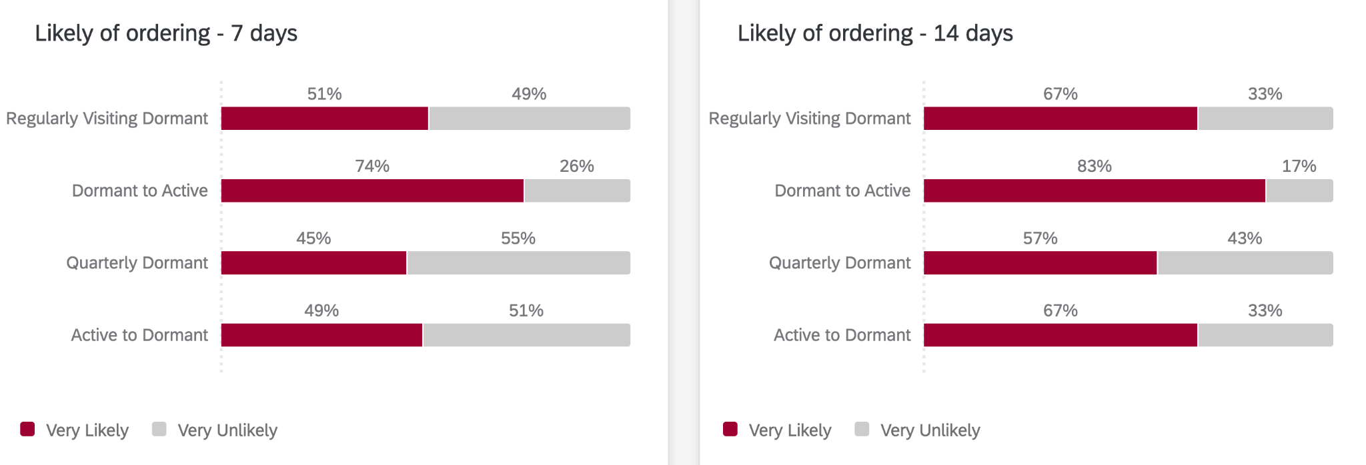

Offering more selection of stores and restaurants with free delivery and offering a loyalty program are the top tested ideas that would drive interest across the groups. The loyalty program is the top motivating idea for Recently Active turned Dormant. Getting instant credits is more appealing to Regularly visiting Dormant and Active to Dormant consumers.

Which of the following, if any, would make your most interested in ordering more from DoorDash than you do today. (choose up to 2)
 | Regularly Visiting Dormant | Dormant to Active | Quarterly Dormant | Active to Dormant
More stores and restaurants offering free delivery or other promotions | 73% | 66% | 68% | 56%
A loyalty program where I can earn benefits for my ordering activity on DoorDash | 51% | 58% | 57% | 58%
Instant credits from customer support when I experience an delivery issue | 23% | 19% | 19% | 23%
Better store or restaurant selection | 19% | 16% | 17% | 17%
Inclusion of grocery stores that help support cooking needs or healthier lifestyle | 7% | 10% | 5% | 8%
Including a surprise in every delivery order from DashMart (A DoorDash owned and operate grocery and convenience store) | 6% | 7% | 5% | 8%
Curated lists of the best stores / restaurants to try out | 3% | 5% | 6% | 3%
Featuring more everyday household convenience items you can get from DoorDash (e.g. Tylenol, paper towels, cleaning supplies) | 1% | 1% | 2% | 3%
None of the above | 3% | 3% | 6% | 8%

